Exemplar: Sorting data

**Overview**

In the exercise *Sorting Data* you had to use the Sort feature to reorganize the data so that you could become more familiar with it.

More specifically, you were instructed to complete the following tasks in the worksheet:

* Sort text and numeric data.
* Perform a multi-level **Sort**.

This reading provides you with a step-by-step guide for this process and includes screenshots that you can compare against your own copy. You can also review sorting techniques in the video *Sorting and filtering data in Excel*.

**Step 1: Getting Started**

1. Download the *Adventure Works Inventory.xlsx* file and open it in Microsoft Excel. The workbook contains only one worksheet called **Products**.
2. Highlight the cells **A32** to **I32** and apply a yellow background. From the **Home** tab, select the **Font** group then select the **background color.** This provides a reference point for when the data is being sorted.

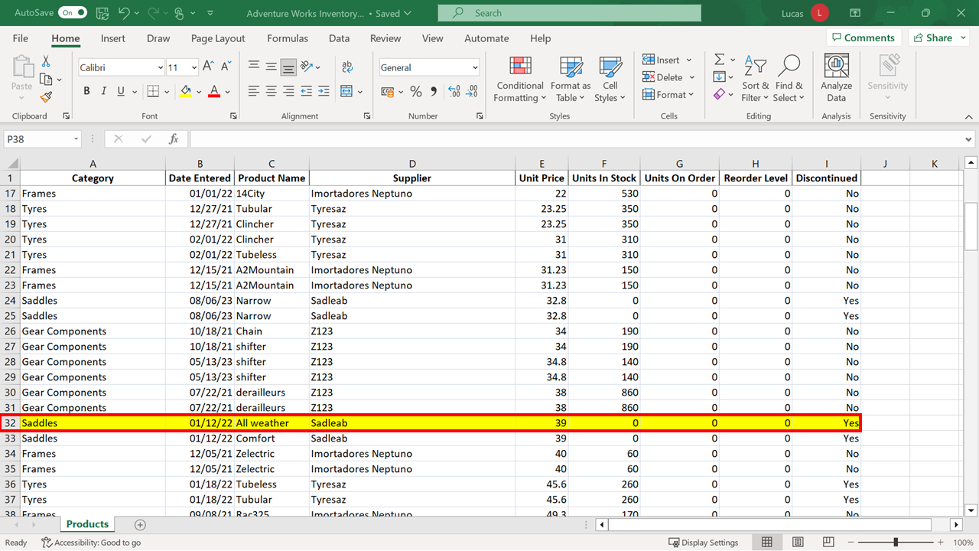

**Step 2: Sorting the Data**

1. You want to view the data organized by **Product Name**. Position the cursor in column **C**. On the **Data** ribbon select **Sort A to Z**.

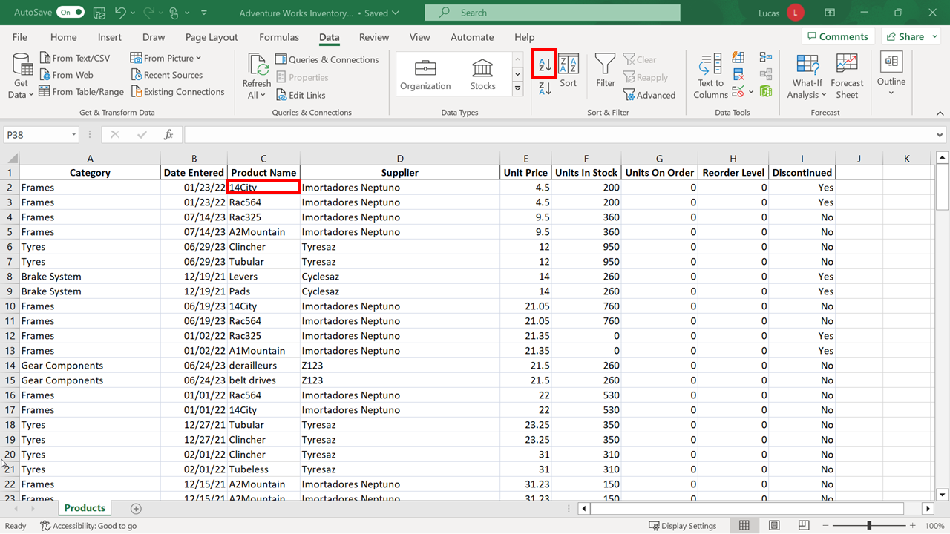

Excel performs an alpha-numeric sort on the data. The text entries appear alphabetically. Any entries starting with a number are positioned at the top of the column.

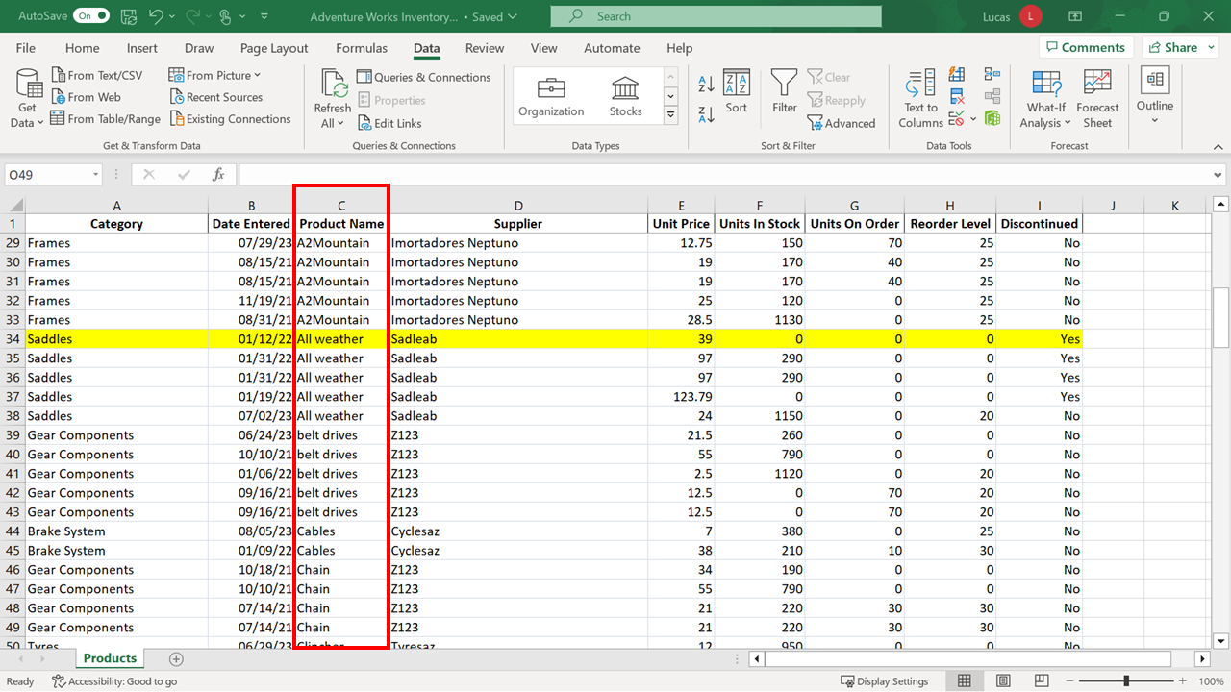

The row that you have shaded yellow has moved to a new location. It is now row **34**.

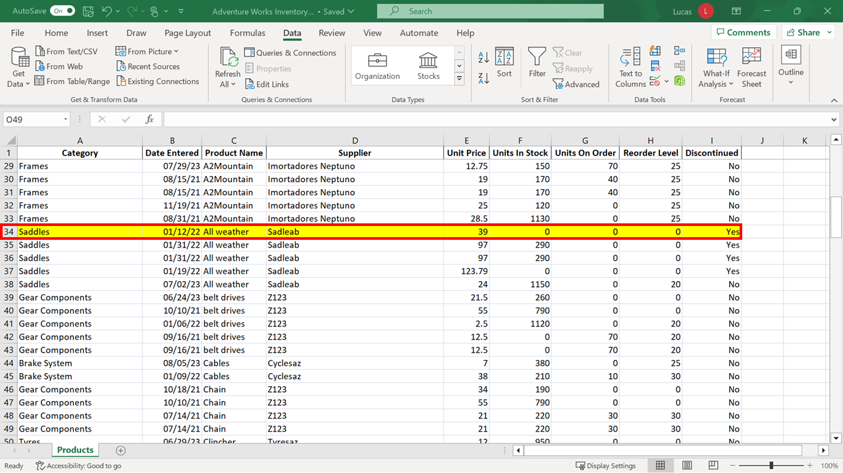

1. You need to view data organized by **Product Name** in descending order. Position the cursor in the **Product Name** column. On the **Data** ribbon choose **Sort Z to A**.

The data block is now resorted. The sort key is still the **Product Name** entries but they appear in reverse order. The row shaded yellow has now moved to row **115**.

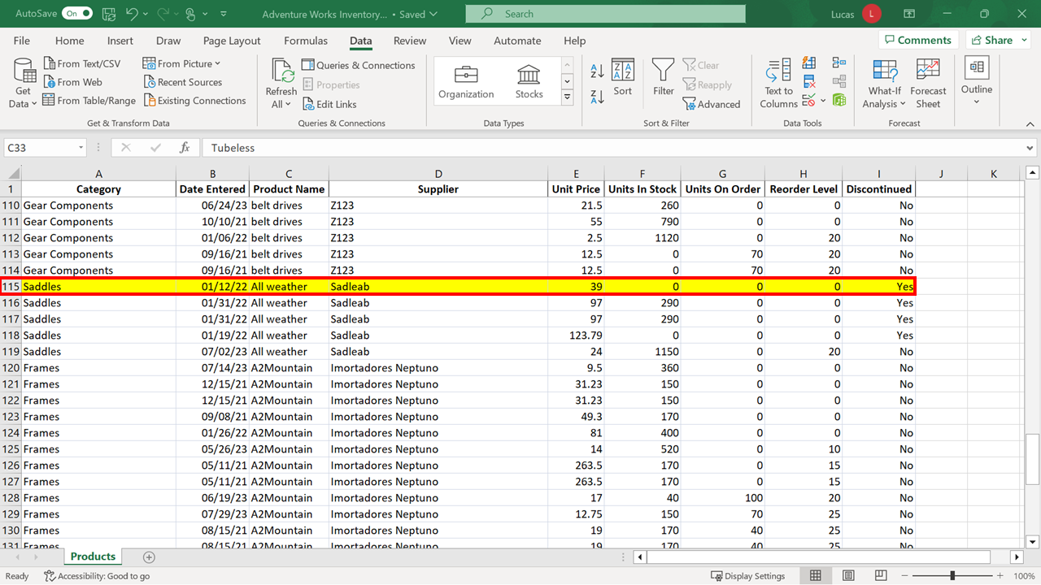

There are still blocks of rows containing the same **Category** entries grouped together because of the way that the information is structured. It would be easy to misinterpret the display of information and believe that row **13** was the last entry for frames, which is not the case.

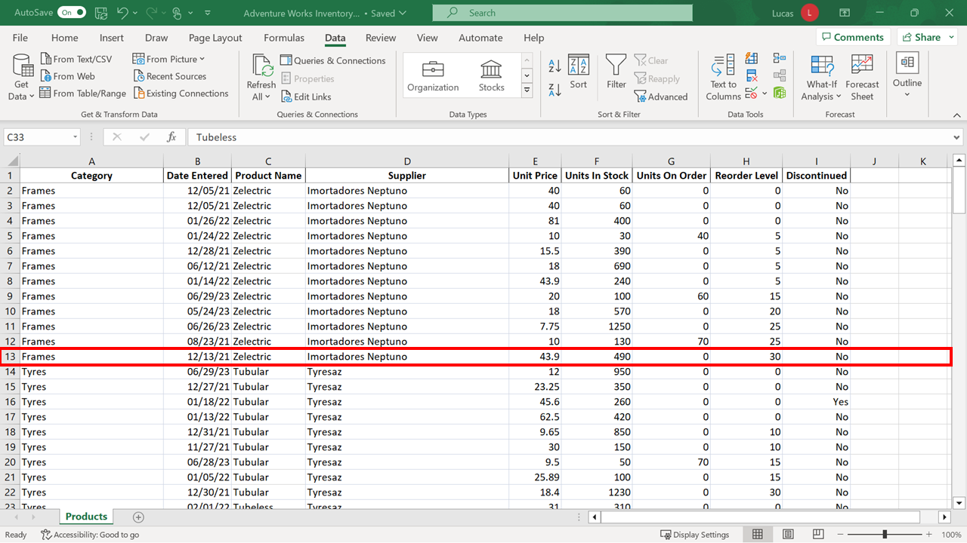

There are additional entries for frames beginning on row **41**.

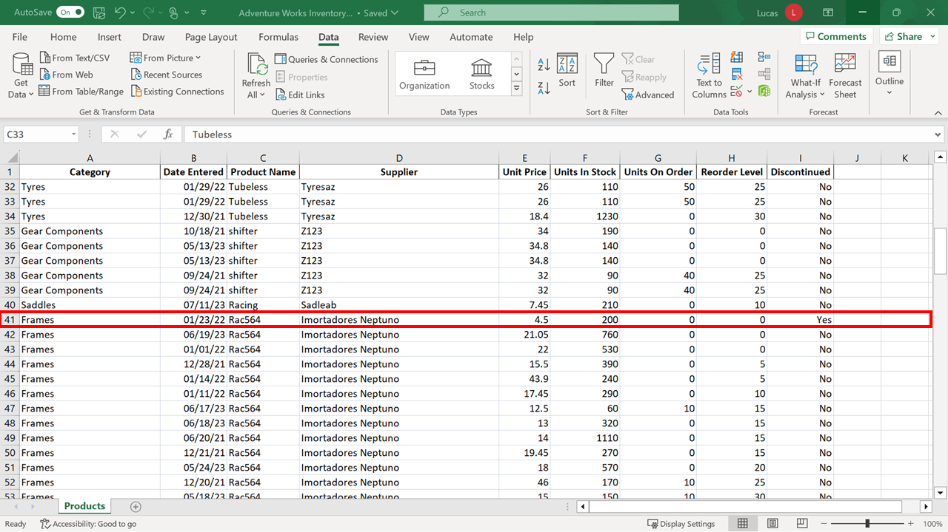

And on row **120**.

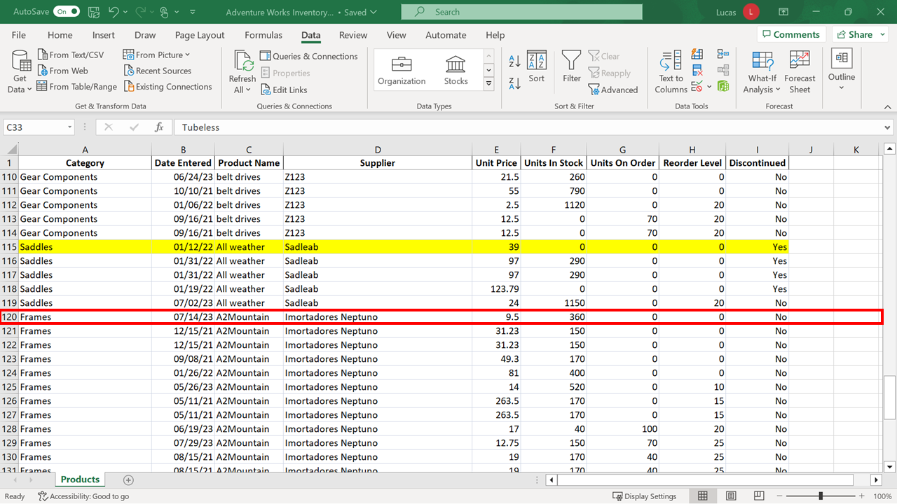

1. Next, you need to sort the data so that the oldest entry is on top. Move the cursor to column **B** which contains the date information. With the cursor in this column, select the **Sort ascending** choice (the **A-Z** button). Excel performs a numeric sort on the data which means that it now appears in date order. The row shaded yellow has been repositioned again and now appears as row **77**.

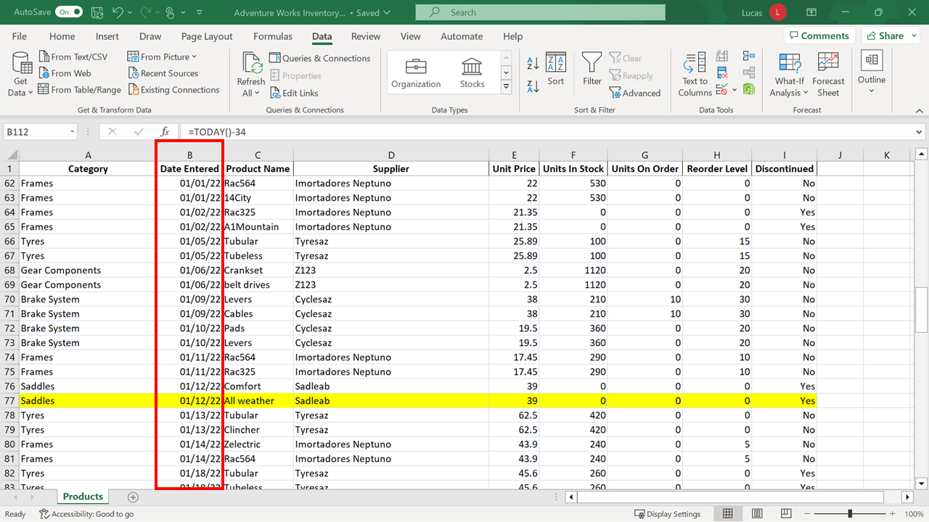

1. Next, you need to sort the data by **Supplier** in ascending order. Position the cursor in the **Supplier** column and then select **Sort** **A to Z** to accomplish this.

A common error is to select a whole column before choosing **Sort**. If you select the column letter **D**, the whole column is highlighted. A warning dialog would appear if you then choose **Sort A to Z** because Excel is aware that there is data around the block of cells you highlighted.

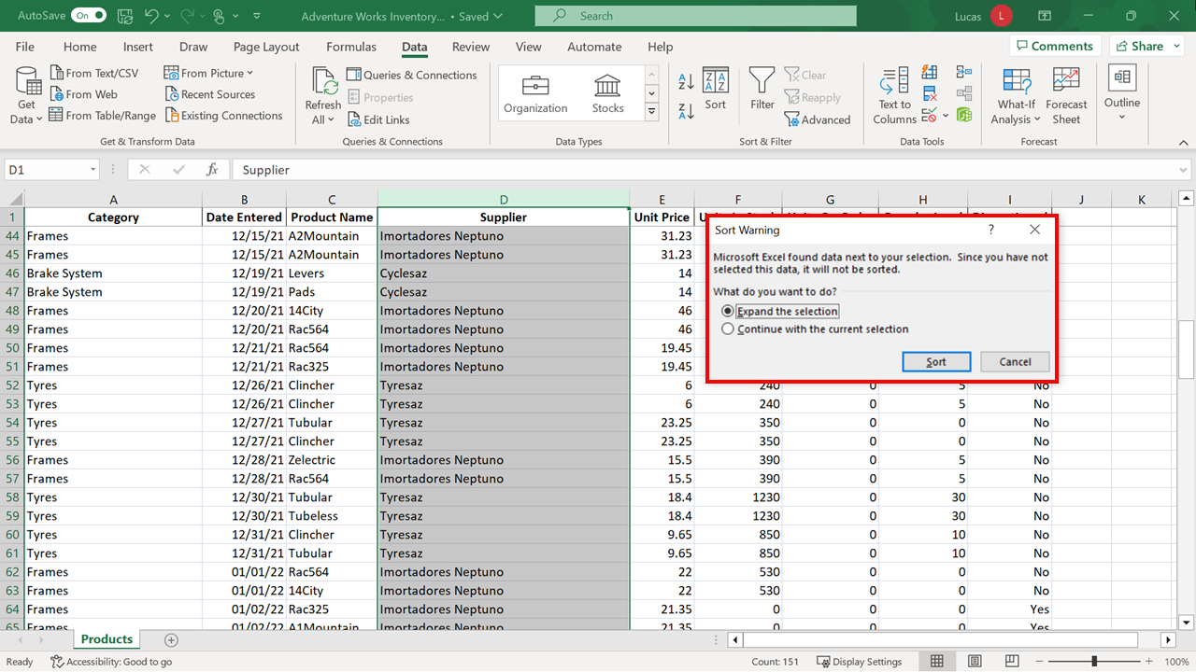

If you selected the **Continue with the current selection** choice in the warning dialog, Excel would sort the content in column **D** independently of the related information in each row.

You can appreciate how this choice made incorrectly, could create serious errors.

**Tip:** If you make a mistake in sorting, you can select **Undo** to reverse the sort and restore the entries to their correct positions.

If you have selected column **D** to see this **Sort Warning** dialog, select a cell anywhere in the spreadsheet to cancel the highlight.

1. You now need to sort the data by two criteria which cannot be achieved using the shortcut **Sort A to Z** or **Sort Z to A** choices. These choices are designed to carry out a single sort. Instead, you select **Sort** from the **Data** tab to begin a multi-level sort operation.

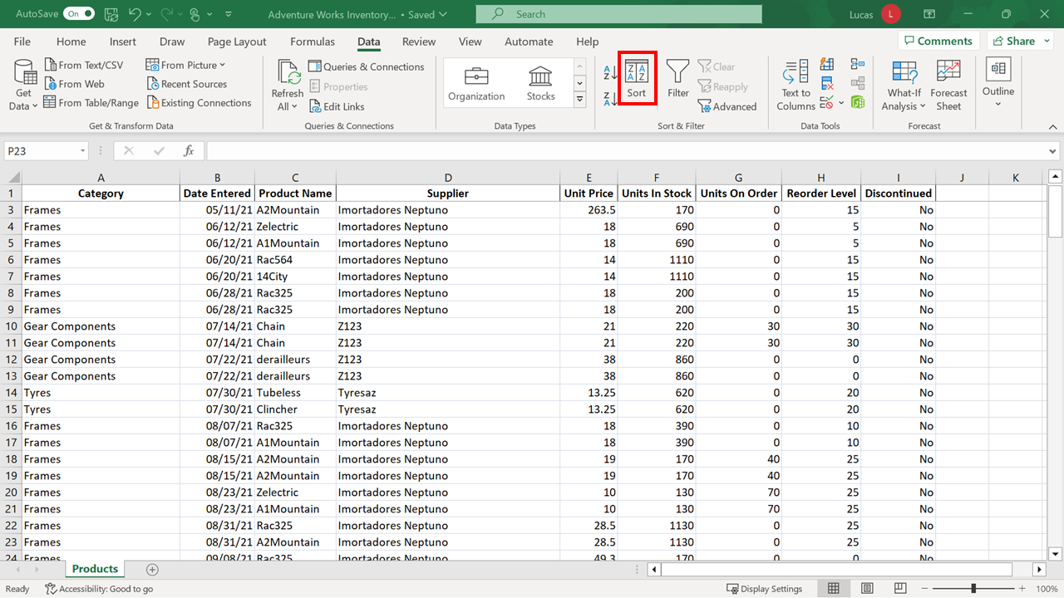

The **Sort** dialog opens with drop-down choices which allow you to customize and control the sort. In the first **Column** drop-down, select **Supplier**.

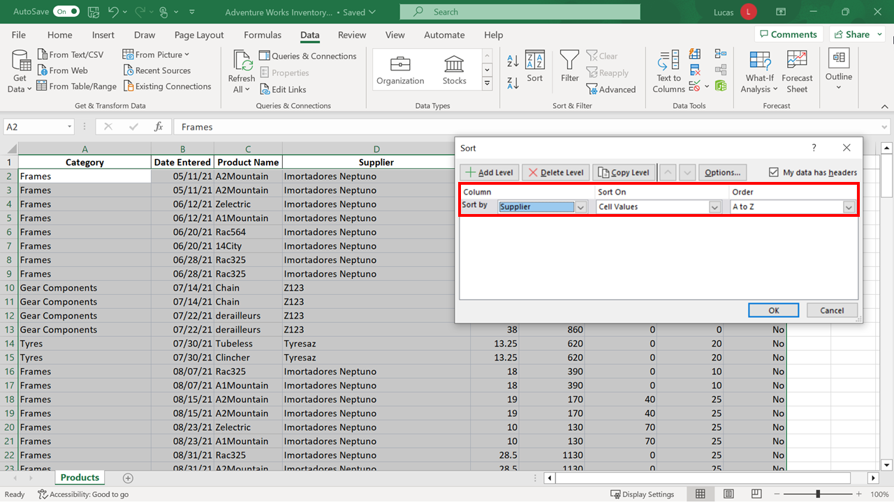

The **Sort On** selection is correctly set to **Cell Values**.

**Tip:** If you click on the drop-down, you will see that it is possible to sort by color in a spreadsheet. (Color can be generated automatically in a spreadsheet using a feature called **Conditional Formatting**. Please refer to the page *Use Conditional Formatting to Highlight information* in the *Additional Resources* reading.)

When you select the **Add Level** choice in the top left of the dialog, another sort line is added. Note that it begins on the left with the words “**Then By**”. This means that the choices made on this line will be the secondary sort. Select **Units in Stock** in the column drop-down and **Largest to smallest** in the **Order** column. Select **OK**.

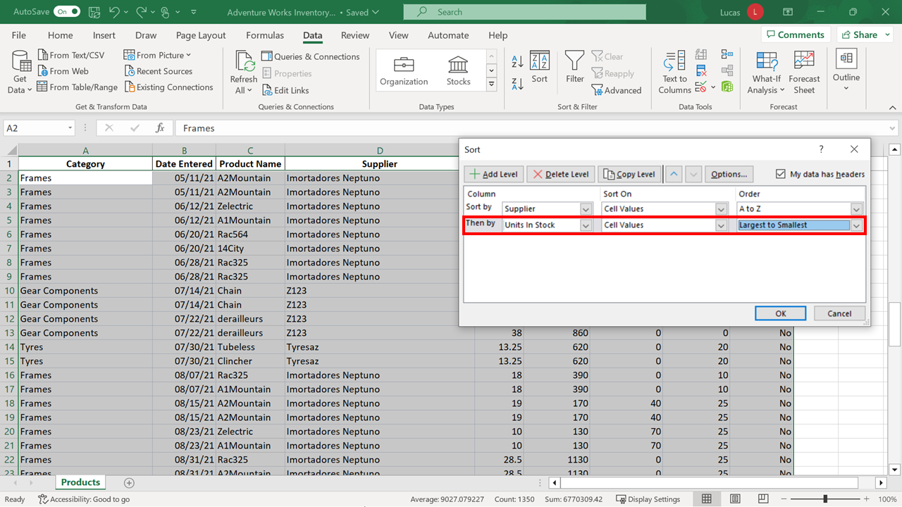

The Sadleab **Supplier** entries are grouped together. The entries are further sorted by **Units in Stock**.

